^{h} & 6th-8th
RHS Baseball Camp
June 1-3 and June 8-10
Liability Release- RISD nor the camp or any individual supervising the camp will be liable for injuries loss or damage. The undersigned agrees that no liability will be asserted and waives all such claims. I hereby certify that my child is in good health and able to participate in Rockwall Baseball Camp. I give permission to the Rockwall Baseball camp to acti for me regarding an emergency medical attention. Initial here:__________

June
- Cost: $125 before May 24 ($150 after)
- June 1-3 or June 8-10 ($50 discount for both)
- Time: 1st-6th 8:00 to 10:00am 7th-9th 10:30-12:30a.m.
- Location: Talley Field (Rockwall High)
- Ages: Incoming 1st-6th & 7th-9th

Walk-ins are always welcome
All sessions coached by Rockwall High School coaches and collegiate players. We will teach basic skills of baseball in a fun, enjoyable atmosphere. Campers will be grouped according to age and / or ability level. Each camper will have lots of fun and learn valuable skills.
Contact Coach Barry Rose for more information Barry.Rose@rockwallisd.org
$50 discount for week 2 if you sign up for both weeks, use code- JFND

June
Week 2 Signup
June 8-10

June

Week 1 Signup
June 1-3

June
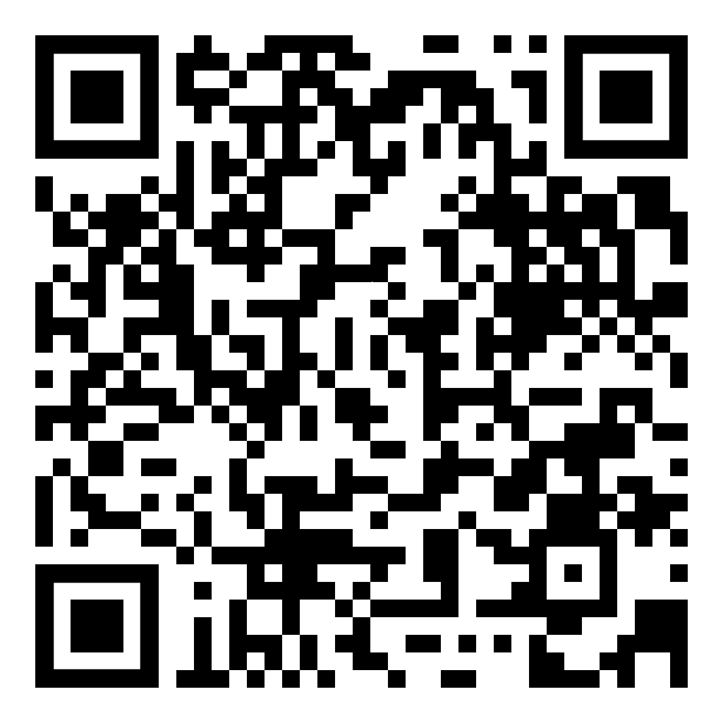
Download the SportsYou app for more camp info: Join code 2JD8Y96S

